**Gracious Germents**

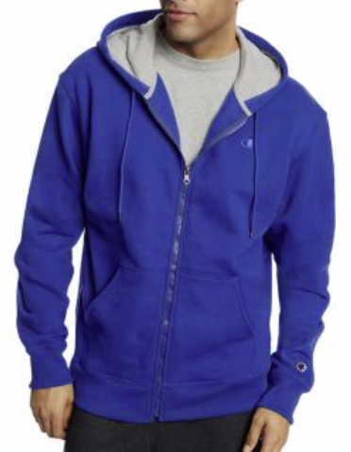

**DESCRIPTION:**

Champion Men’s Powerblend® Fleece Full Zip Jacket

Champion

PowerBlend

S0891 407D55

Units per Pack:1

**ADDITIONAL INFORMATION**

Weight: 0.5 kg

Dimensions: 10 × 8 × 3 cm

Size: S, M, L, XL,

Price: $20.00